 |  | JURONG JUNIOR COLLEGE  JC 2 PRELIMINARY EXAMINATION  Higher 2
CHEMISTRY |  |  | 9647/01
Paper 1 Multiple Choice |  |  | 2 September 2010
 |  |  | 1 hour
Additional Materials: Multiple Choice Answer Sheet
Data Booklet

READ THESE INSTRUCTIONS FIRST

Write in soft pencil.
Do not use staples, paper clips, highlighters, glue or correction fluid.
Write your name, class and shade your exam number on the Answer Sheet in the spaces provided.

There are forty questions on this paper. Answer all questions. For each question there are four possible answers A, B, C and D.
Choose the one you consider correct and record you choice in soft pencil on the separate Answer Sheet.

Read the instructions on the Answer Sheet very carefully.

Each correct answer will score one mark. A mark will not be deducted for a wrong answer.
Any rough working should be done in this booklet.

A Data Booklet is provided. Do not write anything on the Data Booklet.

This document consists of 16 printed pages.
[Turn over
SECTION A

For each question there are four possible answers, A, B, C and D. Choose the one you consider to be correct.

1. | The use of the Data Booklet is relevant to this question.  25.0 cm³ of a 0.270 mol dm⁻³ Fe²⁺ solution was pipetted out into a conical flask and an equal volume of sulfuric acid was added to it before titrating against KMnO₄(aq). 27.60 cm³ of KMnO₄(aq) was required for complete reaction.  What is the concentration, in mol dm⁻³, of the KMnO₄(aq) used?
 | A | 1.22
 | B | 0.245
 | C | 0.0978
 | D | 0.0489

2. | Carbon monoxide, CO, is a colourless, odourless and toxic gas. It is formed as a result of partial oxidation of carbon-containing compounds. The maximum safe toleration level of CO in air is 50 ppm. (1 ppm = 1 mg / kg)  How many CO molecules are present in 1 kg of air at this maximum safe toleration level?
 | A | 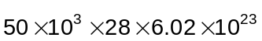
 | B | 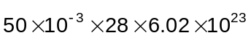
 | C | 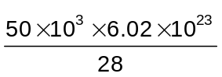
 | D | 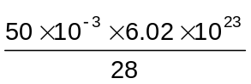

3. | Which of the following ions will be deflected the most when passed through an electric field?
 | A | 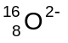 | B | 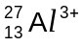 | C | 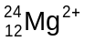 | D | 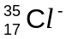

4.  5000  10000  15000  20000  25000  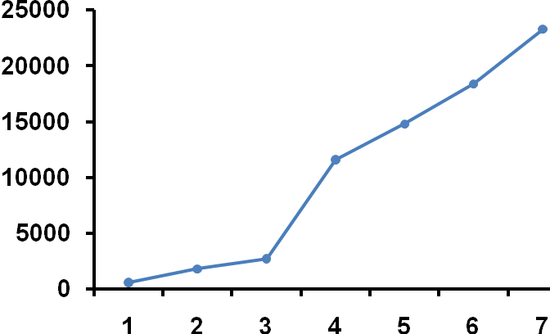 | The two graphs below show the ionisation energies (in kJ mol⁻¹) of the outermost seven electrons of elements Q and R respectively.  IE / kJ mol⁻¹  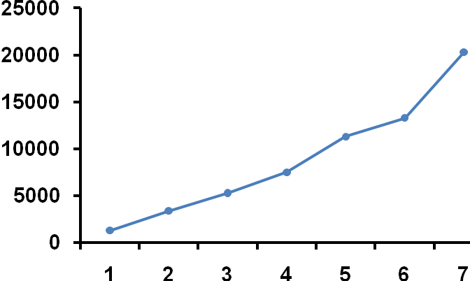  IE / kJ mol⁻¹  Element R  Element Q  25000  20000  15000  10000  5000  2  3  4  5  6  2  3  4  5  6  7  1  7  1  With reference to the two graphs above, what is the formula of the compound likely to be formed between Q and R?
 | A | RQ₂ | B | QR₄ | C | Q₂R₃ | D | Q₃R₂

5. | At 298 K, bulb G contains 2 dm³ of argon gas at 2 kPa and bulb H contains 1 dm³ of neon gas at 1 kPa. Bulbs G and H are connected by a 5 dm³ chamber, as shown below. The volume of the connecting tubes can be assumed to be negligible.  5 dm³ chamber  Ar  Ne  G  H  The gases are mixed when the two taps are opened at constant temperature.  What is the final pressure, in kPa?
 | A |  | B | 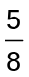 | C | 1 | D | 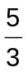

6. | Which of the following statements is correct?
 | A | The Cl−P−Cl bond angle in PCl₃ is 120º.
 | B | Both SO₂ and CO₂ molecules are bent in shape.
 | C | C−O bond has a larger dipole moment than C−N bond.
 | D | The carbon atoms in benzene and C₂H₂ are all sp² hybridised.

7. | Which of the following pairs consist of a polar molecule I and a non-polar molecule II?
 |  | Molecule I | Molecule II
 | A | BCl₃ | BeCl₂
 | B | trans-ClCH=CHCl | cis-ClCH=CHCl
 | C | Al₂Cl₆ | AlCl₃
 | D | SCl₄ | PCl₅

8. | The following enthalpy changes are given.  2Cr(s) + O₂(g) → Cr₂O₃(s) ΔH_{f}(Cr₂O₃) = −1120 kJ mol⁻¹  3C(s) + Cr₂O₃(s) → 2Cr(s) + 3CO(g) ΔH_{r}= +790 kJ mol⁻¹  What is the standard enthalpy change of formation of CO(g), represented by the following equation, in kJ mol⁻¹?  C(s) + O₂(g) → CO(g)
 | A | −110
 | B | −330
 | C | −637
 | D | −1910

9. | The values of some ΔH terms for anhydrous MgCl₂ are given in the table below.  Calculate the enthalpy change of solution of anhydrous MgCl₂, in kJ mol⁻¹.
  Lattice energy of MgCl₂ | −2526 kJ mol⁻¹
  Enthalpy change of hydration of Mg²⁺ | −1890 kJ mol⁻¹
  Enthalpy change of hydration of Cl⁻ | −384 kJ mol⁻¹
 | A | +132
 | B | −132
 | C | +252
 | D | +5184

10. | Pure H₂(g) can react with I₂(g) according to the following equation:  H₂(g) + I₂(g)  2HI(g)  0.10 mol of H₂(g) is mixed with 0.10 mol of I₂(g) in a 2 dm³ closed vessel at 400ºC. Given that the value of K_{c} is 9.00 at 400ºC, calculate the percentage of H₂(g) reacted when the reaction is allowed to proceed until equilibrium.
 | A | 60%
 | B | 75%
 | C | 82%
 | D | 90%

11. | When 5.00 cm³ of a 0.100 mol dm⁻³ base is titrated against 0.100 mol dm⁻³ of aqueous CH₃COOH, the following titration curve is obtained.  Volume of 0.100 mol dm⁻³  of CH₃COOH / cm³  pH  14  12  10  8  6  4  2  0  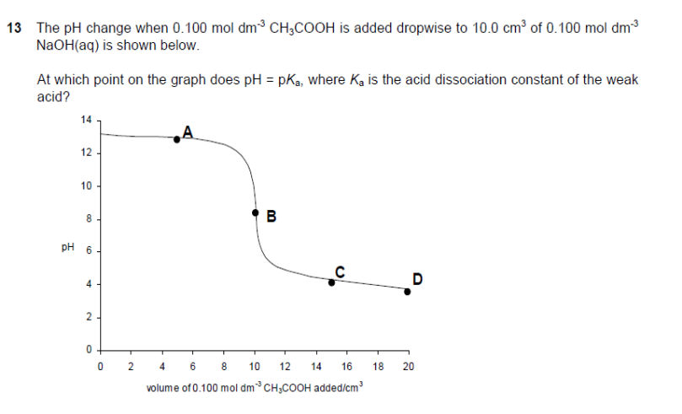  M  P  N  0 2 4 6 8 10 12 14 16 18 20  Which of the following correctly identifies the base used and the point on the curve at which pH = pK_{a}?
 |  | Base used | Point where pH = pK_{a}
 | A | KOH(aq) | M
 | B | Ba(OH)₂(aq) | N
 | C | KOH(aq) | P
 | D | Ba(OH)₂(aq) | P

12. | Which curve is obtained if the rate of reaction is plotted against time for an autocatalytic reaction?
 | A  rate | 0  time | B  rate | 0  time
 | C  rate | 0  time | D  rate | 0  time

13. | The decomposition  2N₂O₅ → 4NO₂ + O₂  is first order with respect to N₂O₅.  In an experiment, 0.10 mol of pure N₂O₅ was put into an evacuated flask. It was found that there was 0.025 mol of N₂O₅ left in the flask 34 minutes later.  Which of the following statements is true?
 | A | There was 0.0625 mol of N₂O₅ left at 17 minutes.
 | B | There will be 0.0125 mol of N₂O₅ left at 68 minutes.
 | C | The amount of NO₂ increased from 0 mol to 0.10 mol in the first 17 minutes.
 | D | The amount of NO₂ in the flask increased by four times in the first 34 minutes.

14. | A typical protein forms several hundreds of hydrogen bonds and several thousands of van der Waals’ forces in folding from primary to tertiary structures. Which of the following thermodynamic state functions of the protein best represents the folding process at low temperature?
 |  | ΔG | ΔH | ΔS
 | A | – | + | +
 | B | – | – | –
 | C | + | + | +
 | D | + | – | –

15.  Energy | The energy profile diagram below represents a reaction that occurs in two steps.  S
Reaction profile
E₂
E₃
products
E₁
reactants
Which of the following statements is correct about the energy profile diagram above?

 | A | S is the intermediate formed.
 | B | E₂ corresponds to the activation energy in the second step of the forward reaction.
 | C | E₁ is the activation energy of the forward reaction.
 | D | E₃ – E₂ is the enthalpy change of the reaction.

16. | When concentrated sulfuric acid is added to separate solid samples of sodium chloride, sodium bromide and sodium iodide, which set of halogen-containing substances is produced?
 | A | HCl, Br₂, I₂ only
 | B | HCl, HBr, HI only
 | C | HCl, HBr, HI, Br₂ and I₂ only
 | D | HCl, HBr, HI, Br₂, I₂ and Cl₂ only

17. | Which of the following electronic configurations of the central metal ions in the complexes is incorrect?  [Ar] represents 1s² 2s² 2p⁶ 3s² 3p⁶.
 |  | Complex | Electronic configuration
 | A | [Zn(NH₃)₄]²⁺ | [Ar] 3d¹⁰
 | B | [Ni(CN)₆]^{4–} | [Ar] 3d⁸
 | C | [CoCl₄]^{2–} | [Ar] 3d⁶
 | D | [Cr(H₂O)₅(SCN)]²⁺ | [Ar] 3d³

18. | In this question, R represents a phenyl group.  2-bis(diphenylphosphino)ethane, R₂P(CH₂)₂PR₂, is a commonly used ligand in coordination chemistry. Some amount of R₂P(CH₂)₂PR₂ is added to a solution containing 0.02 mol of Fe³⁺(aq) ions. 0.06 mol of R₂P(CH₂)₂PR₂ is required to displace all the water ligands.  Which of the following statements is not true?
 | A | The formula of the complex formed is [Fe(R₂P(CH₂)₂PR₂)₃]³⁺.
 | B | The coordination number of the complex formed is 6.
 | C | R₂P(CH₂)₂PR₂ is a stronger ligand than a water molecule.
 | D | R₂P(CH₂)₂PR₂ can form three dative covalent bonds with Fe³⁺ ion.

19. | What is the total number of geometric isomers in the product formed when the following compound reacts with excess concentrated H₂SO₄?  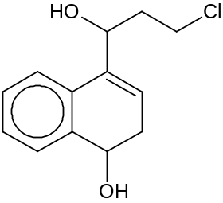
 | A | 2 | B | 4 | C | 6 | D | 8

20. | Excess 2,2−dimethylpropane is reacted with chlorine gas in the presence of ultraviolet light. Which of the following statements is correct regarding this reaction?
 | A | Only one mono-substituted product is formed.
 | B | Only the propagation step involves C−Cl bond formation.
 | C | Only the initiation step of the mechanism involves homolytic fission.
 | D | Both propagation and termination steps produce hydrogen chloride.

21. | Chlorofluorocarbons (CFCs) are commonly used as aerosols, propellants and refrigerants. However in the stratosphere, CFCs can damage the ozone layer through a radical chain reaction.  In which sequence are the following compounds listed in increasing order of their ability to destroy ozone?  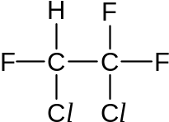  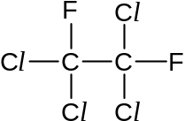
 | A | 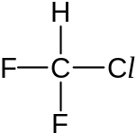 | < |  | <
 | B |  | < |  | <
 | C |  | < |  | <
 | D |  | < |  | <

22. | In the presence of a suitable catalyst, benzene undergoes a reaction with the interhalogen compound ICl.  Which of the following species shows the correct structure of the intermediate formed?  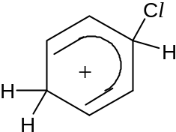
 | A | 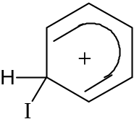 | B | 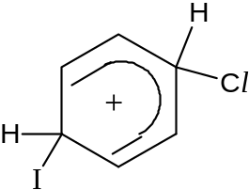
 | C | 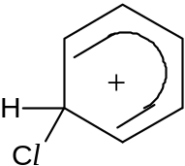 | D

23. | What is the smallest number of carbon atoms needed in a molecule containing only carbon, hydrogen and a single oxygen atom for it to be both chiral and a ketone?
 | A | 4 | B | 5 | C | 6 | D | 9

24. | Which of the following is the correct order of increasing pK_{b} values?  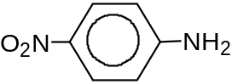  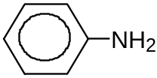
 | A |  |  | CH₂ClCH₂NH₂ | CH₃CH₂NH₂
 | B |  |  | CH₂ClCH₂NH₂ | CH₃CH₂NH₂
 | C | CH₃CH₂NH₂ | CH₂ClCH₂NH₂
 | D | CH₂ClCH₂NH₂ | CH₃CH₂NH₂

25. | An ester U was refluxed with aqueous sodium hydroxide and the resulting mixture was then distilled. The distillate gave a positive triiodomethane test. The residue in the distillation flask gave a white precipitate after acidification.  Which of these could be U?
 | A | CH₃CO₂C₆H₅
 | B | C₆H₅CO₂CH₃
 | C | C₆H₅CO₂CH₂CH₃
 | D | C₆H₅CH₂CO₂CH₂CH₂CH₃

26. | Diels–Alder reaction is one of the most powerful synthetic methods for unsaturated six-membered rings. Under this reaction, a cyclic alkene can be formed from the reaction between an alkene and a diene.  For example:  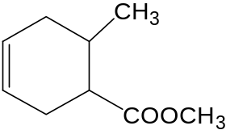  CH₃  COOCH₃  CH=CH + CH₂=CHCH=CH₂  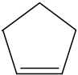  Which of the following shows the organic product when cyclopentene, ,  undergoes Diels-Alder reaction with penta-1,3-diene, CH₂=CHCH=CHCH₃?  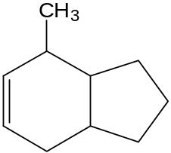  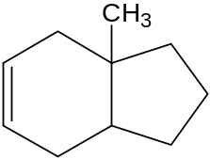
 | A | 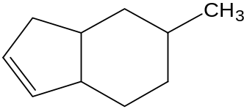 | B | 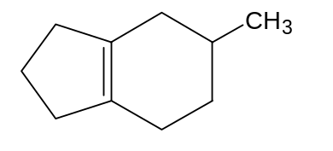
 | C |  | D

27. | When an organic compound V was treated with phosphorous pentachloride, fumes of hydrogen chloride were evolved. When V was warmed with Fehling’s solution, a brick-red precipitate was obtained.  Which of the following is likely to be compound V?
 | A | 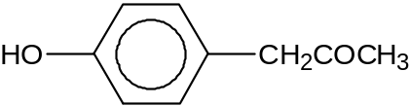
 | B | 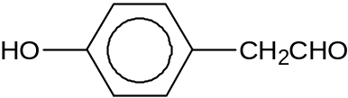
 | C | 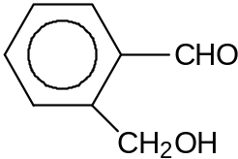
 | D | 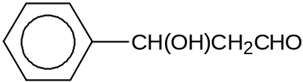

28. | Which of the following reaction schemes will not give a good yield of CH₃CO(CH₂)₃CO₂H?
 |  | Starting material | Step 1 | Step 2
 | A | 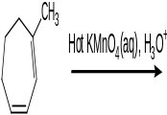  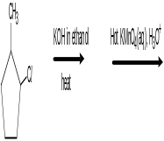 | hot acidified KMnO₄ | –
 | B |  | KOH in ethanol, heat | hot acidified KMnO₄
 | C | CH₃CHCl(CH₂)₃CONH₂ | aqueous KOH, heat | hot acidified KMnO₄
 | D | CH₃CH(OH)(CH₂)₃Cl | KCN in ethanol, heat | hot acidified KMnO₄

29. | In which pair of compounds can one compound be oxidised by hot acidified potassium dichromate(VI) and the other be reduced by sodium borohydride, NaBH₄?
 | C₂H₅CH(OH)C₂H₅ | C₃H₇CHO | C₂H₅CH=CH₂ | 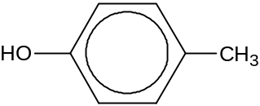
 | W | X | Y | Z
 | oxidised | reduced
A  B  C  D | W  X  Y  Z | X  Y  X  Y

30. | Which of the following best depicts a secondary protein structure? ,  H
 | A | O  CH₂  CH₂  CH  C  CH₂  C  N  H  NH₂  CH  O | B | C  N  H  O
 | C | H  C  N  O | D | H  N  H  C

SECTION B

For each of the questions in this section, one or more of the three numbered statements 1 to 3 may be correct.

Decide whether each of the statements is or is not correct.

The responses A to D should be selected on the basis of

A | B | C | D
1, 2 and 3 are  correct | 1 and 2 only are  correct | 2 and 3 only are  correct | 1 only is  correct

No other combination of statements is used as a correct response.

31. | Which of the following sets contain two covalent chlorides and two covalent oxides?
 | 1 | SiCl₄ BeCl₂ SiO₂ NO₂
 | 2 | BCl₃ AlCl₃ Al₂O₃ Cl₂O
 | 3 | SCl₂ CsCl TiO₂ BaO

32. | Deposits of ammonium compounds have been discovered in areas of high atmospheric pollution. They are believed to arise from the following reaction.  SO₃ + H₂O + 2NH₃ → (NH₄)₂SO₄  Which of the following processes have taken place in the reaction?
 | 1 | ionic bond formation
 | 2 | acid – base neutralisation
 | 3 | dative bond formation

33. | In which of the following conversions does the oxidation number of the nitrogen change by two?
 | 1 | NH₂OH → NH₃
 | 2 | N₂ → NO
 | 3 | NO₂ → HNO₃

The responses A to D should be selected on the basis of

A | B | C | D
1, 2 and 3 are  correct | 1 and 2 only are  correct | 2 and 3 only are  correct | 1 only is  correct

No other combination of statements is used as a correct response.
34. | Phosphorus pentachloride is introduced into an empty gas syringe which has a frictionless air-tight plunger. The gas is allowed to expand until equilibrium is reached at a temperature at which the phosphorus pentachloride partially dissociates.  PCl₅(g)  PCl₃(g) + Cl₂(g)  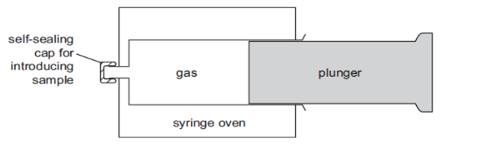  syringe oven  self-sealing cap  for introducing  sample  gas  plunger  Which of the following statements are correct?
 | 1 | At equilibrium, the pressure inside the syringe will be greater than atmospheric pressure.
 | 2 | When the plunger is pushed in, the position of equilibrium shifts to produce more PCl₅(g).
 | 3 | The volume of gas in the syringe at equilibrium will be greater than if no dissociation had occurred.

35. | The use of the Data Booklet is relevant to this question.  to external circuit  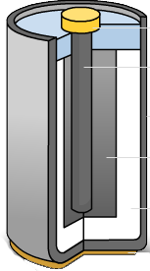  carbon rod  zinc  manganese(IV) oxide  ammonium chloride paste (electrolyte)  In a Leclanche cell shown above, zinc and manganese(IV) oxide react together as follows.  Zn(s) + 2MnO₂(s) + 2H⁺(aq) → Zn²⁺(aq) + Mn₂O₃(s) + H₂O(l)  The electrolyte used is a paste of ammonium chloride. The overall cell potential is 1.50V.  Which of the following statements are true?
 | 1 | The overall cell potential will increase when the acidicity of electrolyte increases.
 | 2 | The reaction at anode is 2MnO₂(s) +2H⁺(aq) + 2e → Mn₂O₃(s) + H₂O(l).
 | 3 | The standard electrode potential of MnO₂/Mn₂O₃ half cell is −0.74V.
The responses A to D should be selected on the basis of

A | B | C | D
1, 2 and 3 are  correct | 1 and 2 only are  correct | 2 and 3 only are  correct | 1 only is  correct

No other combination of statements is used as a correct response.

36. |  | In an experiment, when NaOH(aq) is added to Cr(NO₃)₃(aq), a grey-green precipitate is formed and the precipitate dissolves in excess NaOH(aq) to give a dark green solution.  Which of the following processes occured in this experiment?
 |  | 1 | reduction of Cr³⁺ ions
 |  | 2 | precipitation of Cr(OH)₃
 |  | 3 | formation of dative bonds

37. | Which of the following properties steadily decrease from hydrogen chloride to hydrogen bromide and to hydrogen iodide?
 | 1 | thermal stability
 | 2 | polarity of the H–X bond
 | 3 | boiling point

38. | Which of the following reactions will most likely form a racemic mixture?
 | 1 | CH₃CHO with HCN in trace amounts of alkali at a temperature of 10 to 20ºC.
 | 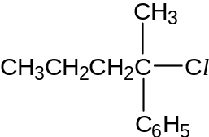  2 | with aqueous sodium hydroxide, heat under reflux.
 | 3 | 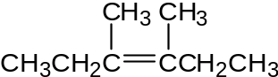  with Br₂ dissolved in CCl₄.

The responses A to D should be selected on the basis of

A | B | C | D
1, 2 and 3 are  correct | 1 and 2 only are  correct | 2 and 3 only are  correct | 1 only is  correct

No other combination of statements is used as a correct response.

39. | Dopamine is a neurotransmitter found in many animals, including vertebrates and invertebrates.  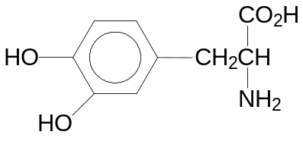  Dopamine  Which of the following statements are correct?
 | 1 | 1 mole of dopamine reacts with 1 mole of HCl(aq).
 | 2 | 1 mole of dopamine reacts with 3 moles of Br₂(aq).
 | 3 | 1 mole of dopamine reacts with 3 moles of Na₂CO₃(aq).

40. | When the apparatus below was used with compound E, an orange precipitate was formed in the right-hand test-tube.  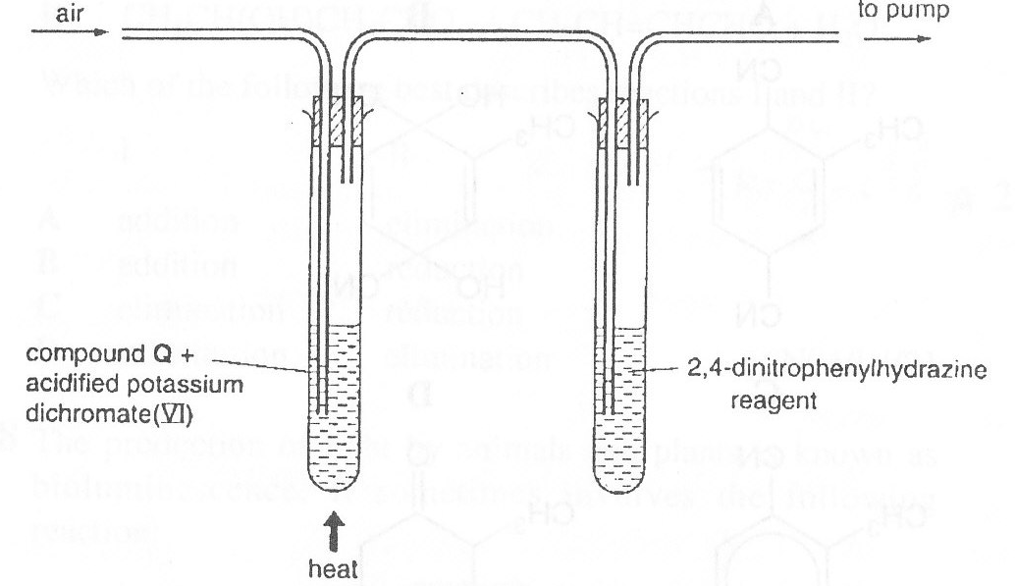  Compound E and acidified potassium dichromate(VI)  to pump  air  heat  2,4-dinitrophenylhydrazine reagent  Which of the following compounds could be compound E?
40. | 1 | CH₃CH(OH)CH₃
40. | 2 | CH₃COOCH(CH₃)₂
40. | 3 | CH₃COOCH₃

